Docker Swarm on Google Compute Engine

This is a follow up of my [Docker Swarm Tutorial](https://rominirani.com/docker-swarm-tutorial-b67470cf8872#.5zdp4a93d). I strongly suggest that you go through that if you are not familiar with the basics of Docker Swarm.

This tutorial builds on the previous tutorial by going through the following:

* Setup a Docker Swarm on [Google Compute Engine](https://cloud.google.com/compute/)
* Experiment multiple scenarios like setting up multiple Swarm Manager, bringing a Swarm Manager down, setting up an Overlay network and more.



*Download a mini book (about 50 pages) that contains both the Docker Swarm Tutorial and Docker Swarm on Google Compute Engine. Click*[*here*](https://goo.gl/w1vMRo)*to download the PDF.*

The first step is to create the Docker Swarm cluster on Google Compute Engine.

**Prerequisites**

This tutorial assumes that you have setup the following on your machine:

* Latest version of [Docker Toolbox](https://www.docker.com/products/docker-toolbox). Ensure that it is 1.12 or higher.
* Latest version of [Google Cloud SDK Tools](https://cloud.google.com/sdk/). Please download it from the link.

**Google Cloud Platform Project**

I suggest that you create a new [Google Cloud Platform Project](https://console.cloud.google.com/) for this tutorial. But if you are familiar with the platform and wish to use an existing project, that is fine too. Note down the Project Id for the Google Cloud Platform project.

On your local machine, where you have already setup Docker Toolbox + Google Cloud Platform tools and assuming that you have the Google Cloud Platform project id handy, **initialize**the project using the gcloud utility that you have setup.

$ gcloud init

and go ahead with the rest of the steps, ensure that you select the zone/region of your choice and most importantly the project id.

To ensure that you are all set, just fire the following command and note if the properties are setup correctly. You should see similar values.

$ gcloud config list  
  
Your active configuration is: [<your-config-name>]

[compute]  
region = <your-selected-region> e.g. us-central1  
zone = <your-selected-zone> e.g. us-central1-a  
[core]  
account = [<](mailto:romin.irani@mindstormsoftware.com)your-email-id>  
disable_usage_reporting = True  
project = <YOUR_GCP_PROJECT_ID>

If the project is not set, I suggest that you do so with the following command:

$ gcloud config set project <YOUR_GCP_PROJECT_ID>

**Creating the Docker Machines**

The first step to creating the swarm is to provision the Docker machines. By that, we mean that we will be provisioning Compute Engine instances. We are going to have the following setup:

* 5 Compute Engine instances, all setup with docker and provisioned using the **docker-machine**utility that is part of the Docker Toolbox.
* We are going to have 3 Managers in the Swarm and 2 Workers in the Swarm. We need to give the names to our Compute Engine instances, so we will name them **mgr-1, mgr-2, mgr-3**and **w-1 & w-2.**

To provision a Docker machine (Host) on compute engine, we use the following command (for mgr-1). Note that we are using the Google Cloud **driver**, specifying the **machine type** (n1-standard-1), giving a **tag**to all our machines and specifying the **google-project-id**. This is standard **docker-machine** create stuff.

$ docker-machine create mgr-1 \   
 -d google \   
 --google-machine-type n1-standard-1   
 --google-tags myswarm  
 --google-project <YOUR_GCP_PROJECT_ID>  
Running pre-create checks…  
(mgr-1) Check that the project exists  
(mgr-1) Check if the instance already exists  
Creating machine…  
(mgr-1) Generating SSH Key  
(mgr-1) Creating host…  
(mgr-1) Opening firewall ports  
(mgr-1) Creating instance  
(mgr-1) Waiting for Instance  
(mgr-1) Uploading SSH Key  
Waiting for machine to be running, this may take a few minutes…  
Detecting operating system of created instance…  
Waiting for SSH to be available…  
Detecting the provisioner…  
Provisioning with ubuntu(systemd)…  
Installing Docker…  
Copying certs to the local machine directory…  
Copying certs to the remote machine…  
Setting Docker configuration on the remote daemon…  
Checking connection to Docker…  
Docker is up and running!  
To see how to connect your Docker Client to the Docker Engine running on this virtual machine, run: docker-machine env mgr-1

We do the same for mgr-2, mgr-3, w-1 and w-2. On successful creation, we can use the docker-machine ls command to check on our Docker machines. The output should be similar to the one that I got below (Note that I have removed the SWARM and the ERRORS column from the output):

$ docker-machine ls  
NAME ACTIVE DRIVER STATE URL DOCKER   
mgr-1 — google Running tcp://130.211.199.228:2376 v1.12.1  
mgr-2 — google Running tcp://104.154.244.185:2376 v1.12.1  
mgr-3 — google Running tcp://104.154.56.35:2376 v1.12.1  
w-1 — google Running tcp://107.178.213.86:2376 v1.12.1  
w-2 — google Running tcp://8.34.214.144:2376 v1.12.1

At his point, you could also use the gcloud compute instances list command to see the list of VMs that have been provisioned. In the listing you should see Compute Engine VMs as listed below:

$ gcloud compute instances list  
NAME ZONE MACHINE_TYPE PREEMPTIBLE INTERNAL_IP EXTERNAL_IP STATUS  
mgr-1 us-central1-a n1-standard-1 10.240.0.2 130.211.199.228 RUNNING  
mgr-2 us-central1-a n1-standard-1 10.240.0.3 104.154.244.185 RUNNING  
mgr-3 us-central1-a n1-standard-1 10.240.0.4 104.154.56.35 RUNNING  
w-1 us-central1-a n1-standard-1 10.240.0.5 107.178.213.86 RUNNING  
w-2 us-central1-a n1-standard-1 10.240.0.6 8.34.214.144 RUNNING

Each of the VMs has been assigned an internal and external IP. The status of all the machines is also in RUNNING state.

**Creating the Swarm**

In the [Docker Swarm tutorial](https://rominirani.com/docker-swarm-tutorial-b67470cf8872#.5zdp4a93d), we had seen how to create the Swarm. To reiterate, we are going to create a Swarm with:

* 3 Manager nodes (This will make 1 as as the LEADER and the other 2 as Available)
* 2 Worker nodes

**SSH into Google Compute Engine VMs**

One of the nice features of Google Compute Engine VMs is that you have a SSH button right next to your list of Compute Engine VMs, wich you can click and get into a SSH session with that VM.

If you go to the Google Cloud Console and then select Compute Engine, you will see a list that looks something like this:

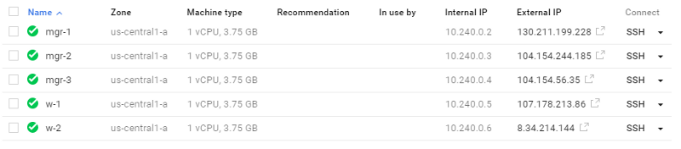

Notice the SSH button to the extreme right for each machine that we created. Click on that to launch the SSH session for any of the machines. I will use the title SSH to mgr-1 session and so on to indicate which machine I am on.

*Note: You can also use the***docker-machine env***command on your local machine to set the environment variables that will allow the docker client to connect to a specific machine. If you are comfortable with it, use it by all means.*

*Note: You will notice the****sudo****prefix before the docker commands. If you want to avoid that, you should consider adding the user with root privileges to the docker user group. E.g. sudo usermod -aG docker <user_name>*

**Initialize the Swarm**

First up, note down the Internal IP address of the **mgr-1**instance. You will find that in the Compute Engine VM listing that we saw about in my case, it is 10.240.0.2.

* SSH to mgr-1 docker machine
* Give the following command:

romin_irani@mgr-1:~$ sudo docker swarm init — advertise-addr 10.240.0.2

Swarm initialized: current node (6l6qh3d1b6hps9ic095wsor27) is now a manager.

To add a worker to this swarm, run the following command:   
docker swarm join \   
--token SWMTKN-1–4lon4th27l53xvrpruohbld5lciux02rxs9go9fdt2672cdkhu-69j9grxvmri7wni2k134m4dmw \   
10.240.0.2:2377

To add a manager to this swarm, run ‘docker swarm join-token manager’ and follow the instructions.

romin_irani@mgr-1:~$

At this point, we have only one node in our Swarm as shown below:

romin_irani@mgr-1:~$ sudo docker node ls  
ID HOSTNAME STATUS AVAILABILITY MANAGER STATUS  
6l6.. * mgr-1 Ready Active Leader

To join the other nodes as workers or managers, we just have to know what is the token and ip to use as part of the docker swarm join command. This is made easy to simply executing the join-token <role> on the current master i.e. mgr-1 and noting down the commands:

romin_irani@mgr-1:~$ sudo docker swarm join-token manager  
To add a manager to this swarm, run the following command:  
 docker swarm join \  
 — token SWMTKN-1–4lon4th27l53xvrpruohbld5lciux02rxs9go9fdt2672cdkhu-43c7vexnensp8mkv  
wl09preu7 \  
 10.240.0.2:2377  
   
romin_irani@mgr-1:~$ sudo docker swarm join-token worker  
To add a worker to this swarm, run the following command:  
 docker swarm join \  
 — token SWMTKN-1–4lon4th27l53xvrpruohbld5lciux02rxs9go9fdt2672cdkhu-69j9grxvmri7wni2  
k134m4dmw \  
 10.240.0.2:2377

You can now open up SSH sessions on each of the nodes. Remember that on mgr-2 and mgr-3 , we want to execute the command to join as a manager. And on w-1 and w-2 nodes, we want to execute the command to join as a worker.

Complete the following and your Docker Swarm is now ready.

If we run the command to list down the Swarm nodes on mgr-1, we should get the following output:

romin_irani@mgr-1:~$ sudo docker node ls  
ID HOSTNAME STATUS AVAILABILITY MANAGER STATUS  
01l.. mgr-2 Ready Active Reachable  
4e3.. mgr-3 Ready Active Reachable  
6l6.. * mgr-1 Ready Active Leader  
7xo.. w-1 Ready Active   
8ie.. w-2 Ready Active

You can see from the output above that we have 5 nodes running. Our mgr-1 (Manager) from where we launched the Swarm cluster is now a **Leader**. The other managers are in a **Reachable** state.

Great. Everything looks good for now.

**Creating the Overlay Network**

Let us create an overlay network now. An overlay network supports multi-host networking. We are going to be using the overlay network for our swarm services. When you specify an overlay network for your services, Swarm automatically assigns addresses to the containers.

Stay in the SSH session for **mgr-1**. We can look at our current list of networks as follows:

romin_irani@mgr-1:~$ sudo docker network list  
NETWORK ID NAME DRIVER SCOPE  
d4b360ee71b4 bridge bridge local 9a55643d34e8 docker_gwbridge bridge local b6348ecb0afa host host local dzzo90eqcmt2 ingress overlay swarm 46f4630544d0 none null local

You will notice that at the local scope, you have the default bridge and the host network. You will also notice that Docker Swarm created a default overlay network called ingress. As per the [documentation](https://docs.docker.com/engine/swarm/key-concepts/), “the swarm manager uses ingress load balancing to expose the services you want to make available externally to the swarm.”

Let us go ahead now and create our own overlay network named **nw1**. So on the manager node (**mgr-1**) do the following:

$ sudo docker network create --driver overlay nw17ffh8lexsm9fhiukslkyiml02

We can now inspect the list of network services as follows:

romin_irani@mgr-1:~$ sudo docker network list  
NETWORK ID NAME DRIVER SCOPE  
d4b360ee71b4 bridge bridge local 9a55643d34e8 docker_gwbridge bridge local b6348ecb0afa host host local dzzo90eqcmt2 ingress overlay swarm 46f4630544d0 none null local **7ffh8lexsm9f nw1 overlay swarm**

You can see that the overlay network (named **nw1**) is created.

**Creating the Service**

Similar to the tutorial on Docker Swarm, we are going to create our standard NGINX service with 6 replicas. This time however, we are going to use the **overlay network** (**nw1**) that we created so that we can later on see how it all comes together when working with multiple services.

On the **mgr-1** node, execute the following command:

romin_irani@mgr-1:~$ sudo docker service create --replicas 6   
--network nw1 -p 80:80/tcp --name nginx nginx  
0omlto8a98zahgbsqs0ajz159

We can see the services as follows:

romin_irani@mgr-1:~$ sudo docker service ls  
ID NAME REPLICAS IMAGE COMMAND  
0omlto8a98za nginx 6/6 nginx

We can see that 6 containers have been launched for NGINX image. To understand the distribution of these **6 containers** on the **5 nodes** that we have, we can use the following command:

romin_irani@mgr-1:~$ sudo docker service ps nginx  
ID NAME IMAGE NODE DESIRED STATE CURRENT STATE   
9z* nginx.1 nginx mgr-2 Running Running 32 seconds ago   
6e* nginx.2 nginx w-1 Running Running 32 seconds ago   
1o* nginx.3 nginx w-1 Running Running 32 seconds ago   
6n* nginx.4 nginx mgr-1 Running Running 32 seconds ago   
8l* nginx.5 nginx w-2 Running Running 32 seconds ago   
8p* nginx.6 nginx mgr-3 Running Running 32 seconds ago

We can see that the Swarm Manager distributed the containers across all the 5 nodes : running 2 containers on **worker node w-1** and distributing the other containers equally across all the remaining nodes.

So at this point, we have the standard NGINX container running on our 5 nodes. These 5 nodes are nothing but our VMs i.e. Google Compute Engine instances. And if you recollect, each of these Compute Engine instances were provided both an internal IP Address and an external IP Address.

You could list out the output of the **gcloud compute instances list** command again. You could either use that from your laptop or just go to the Compute Engine instances list in the Google Cloud console.



**Internal Connectivity**

You can SSH into any of the Compute Engine instances. Notice that the Internal IPs from the list of instances above. Simply use ‘curl <InternalIPAddress>’ for any of the instances and you should get back the HTML content of the default NGINX home page. So in short, the instances can communicate to each other internally via the Internal IP Addresses.

**External Connectivity**

To do this, we will need to create a Firewall rule to allow traffic from outside targetted towards port 80 and we should target the Compute Engine instancces that we had tagged earlier with the **myswarm** tag, which we used as value for the

--google-tags myswarm

while creating the Docker machine.

From the gcloud utility on your local machine, fire the following command:

$ gcloud compute firewall-rules create my-swarm-rule --allow tcp:80   
--description "nginx service" --target-tags myswarm

On successful creation, you will notice from your web Google Cloud console, that in the Networking → Firewalls list, you have an entry as shown below:

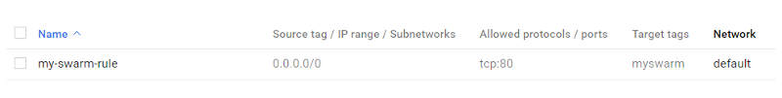

The details of which are shown below:

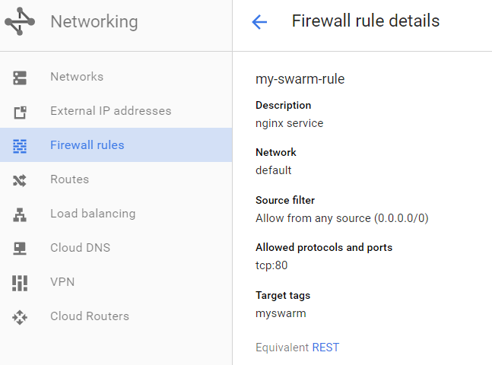

Now, if you hit any of the external IP Addresses from the Compute Engine instances list, you will get the NGINX home page as shown below, when I access one of the External IPs:

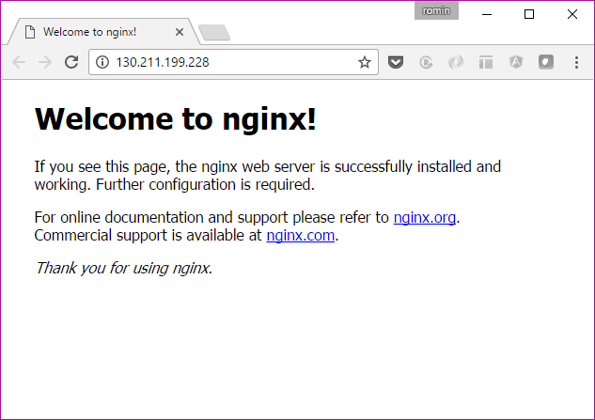

So, we are now able to access our service from any of the External IP addresses. But this is not what we want to do. We want to put these machines behind a Load Balancer. And simply by hitting the Load Balancer public IP, the traffic should get routed to any of the instances i.e. the nodes in our Docker Swarm Cluster.

For this, we need to create the Load Balancer, that Google Compute Engine provides.

**Creating the Load Balancer**

To create the Load Balancer, do the following:

* Go to Google Cloud console.
* Go to Networking → Load Balancing. Click on **Create Load Balancer**button.
* You will see 3 options, click the **Start configuration**button in the **TCP Load Balancing** option as shown below:

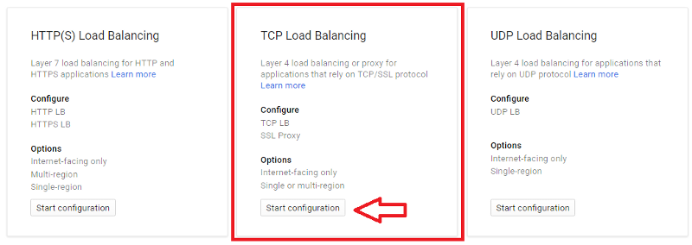

* Click on Continue in the next section and then you will reach the configuration for Backend and Frontend as shown below. Give your Load Balancer a name as shown below:

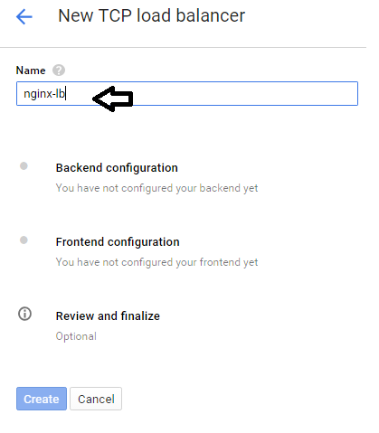

* Click on Backend configuration next. Select the **region**for your load balancer — I went with the ones in which I had my instances. Then select existing instances, and pick all the nodes (compute engine instances) that we created. Finally select a standard http port 80 healthcheck. This will enable the load balancer to check the health of each nodes. And since our nginx service is running on port 80, a simple healthcheck on port 80 is good enough for now.

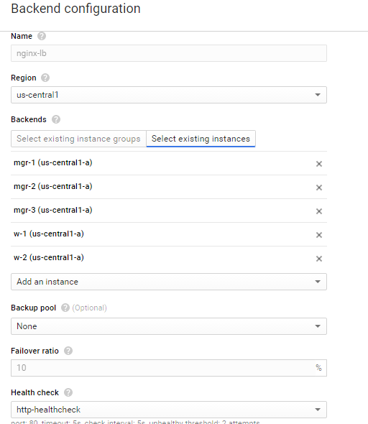

* Now go to **Front end configuration**and enter the port as 80. We are going with an ephemeral ip for now, but you could also get yourself a Static IP Address.

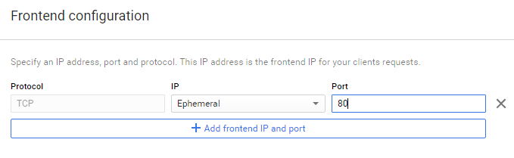

* Your review and finalize should look this:

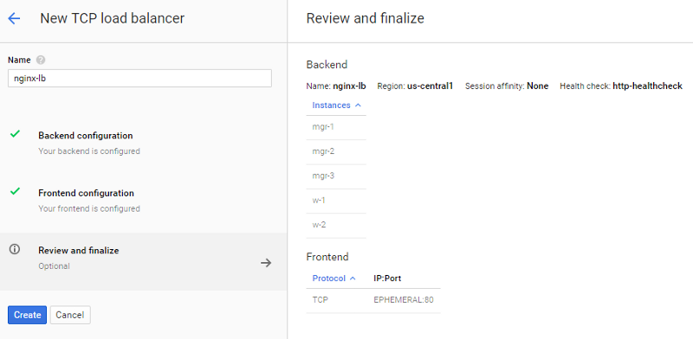

Click on **Create**button to provision your Load Balancer. Give it some time.

Once it is created, you can inspect it by clicking on the Load Balancer name. The details are shown below:

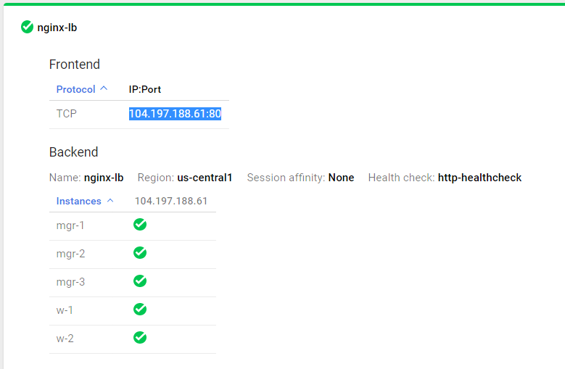

You can see that the Frontend part of it has been assigned an IP Address, which has been highlighted above. We can now hit this IP Address on port 80 and it will divert the traffic to be served by any of the healthy instances. All these instances are nothing but our nodes and since our NGINX service is running on these nodes on port 80, any of them will be able to serve it.

Go ahead, launch the browser and visit the Load Balancer IP in the browser. You should be fine:

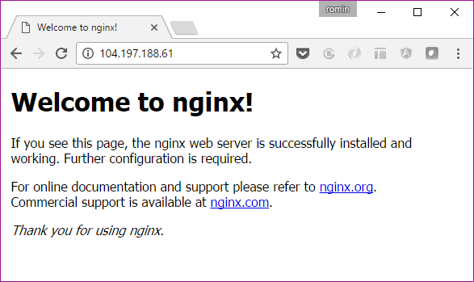

Additionally, if you go to the list of Compute Engine instances, you will see that the nodes are now in use by our Load Balancer as shown below:

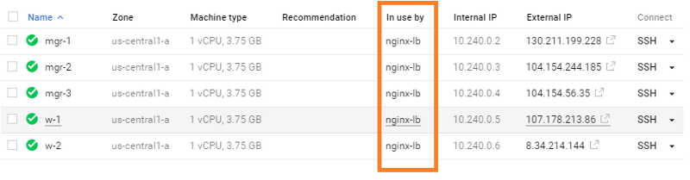

We are looking good for now. Let us do a little deep dive into our overlay network and see what is going on.

**Understand the overlay network**

Let us go back to the list of networks that we have. We can do that from any node. I suggest that you SSH first to mgr-1 and do the following:

$ sudo docker network list  
NETWORK ID NAME DRIVER SCOPE  
d4b360ee71b4 bridge bridge local   
9a55643d34e8 docker_gwbridge bridge local   
b6348ecb0afa host host local   
dzzo90eqcmt2 ingress overlay swarm   
46f4630544d0 none null local   
7ffh8lexsm9f nw1 overlay swarm

Notice again that created an overlay network **nw1**and its Network ID is **7ffh8lexsm9f**.

Let me also show you the output from the node listing in our cluster to understand where our 6 containers are currently running:

romin_irani@mgr-1:~$ sudo docker service ps nginx  
ID NAME IMAGE NODE DESIRED STATE CURRENT STATE   
9z* nginx.1 nginx mgr-2 Running Running 32 seconds ago   
6e* nginx.2 nginx w-1 Running Running 32 seconds ago   
1o* nginx.3 nginx w-1 Running Running 32 seconds ago   
**6n* nginx.4 nginx mgr-1 Running Running 32 seconds ago**    
8l* nginx.5 nginx w-2 Running Running 32 seconds ago   
8p* nginx.6 nginx mgr-3 Running Running 32 seconds ago

You can notice that there is only one container running on node **mgr-1**and that it’s the **nginx.4 container**.

On the manager (**mgr-1**) node, you can now inspect the network by giving the following command:

romin_irani@mgr-1:~$ sudo docker network inspect nw1  
[  
 {  
 "Name": "nw1",  
 **"Id": "7ffh8lexsm9fhiukslkyiml02",**  
 **"Scope": "swarm",  
 "Driver": "overlay",**  
 "EnableIPv6": false,  
 "IPAM": {  
 "Driver": "default",  
 "Options": null,  
 "Config": [  
 {  
 "Subnet": "10.0.0.0/24",  
 "Gateway": "10.0.0.1"  
 }  
 ]  
 },  
 "Internal": false,  
 "Containers": {  
 "3d32b7128776a8398e741ad542427f0edee0f165c3d8de66fd9b3777f6194a24": {  
 "Name": "**nginx.4**.6nlj4cg74wxx76r6cumwrnfto",  
 "EndpointID": "2a99474d5e67433e7b0a371fb56225ec8d330a0af4fbe9d573b7c10e890292b3",  
 "MacAddress": "02:42:0a:00:00:03",  
 "IPv4Address": "10.0.0.3/24",  
 "IPv6Address": ""  
 }  
 },  
 "Options": {  
 "com.docker.network.driver.overlay.vxlanid_list": "257"  
 },  
 "Labels": {}  
 }  
]

First notice the Network ID that is the same value as what we have seen in the network listing and that it is a swarm overlay network.

Now, notice the interesting part in the section for **Containers**. You will find that it is running one container, which is what we expect and you will see the same name i.e. nginx.4. What this means is that 1 container is bound to that overlay network.

Now, go to w-1 or any other worker node i.e. SSH into it. In our output, we have 2 containers (**nginx.2 and nginx.3**) running on that node, as highlighted below:

romin_irani@mgr-1:~$ sudo docker service ps nginx  
ID NAME IMAGE NODE DESIRED STATE CURRENT STATE   
9z* nginx.1 nginx mgr-2 Running Running 32 seconds ago   
**6e* nginx.2 nginx w-1 Running Running 32 seconds ago   
1o* nginx.3 nginx w-1 Running Running 32 seconds ago**6n* nginx.4 nginx mgr-1 Running Running 32 seconds ago   
8l* nginx.5 nginx w-2 Running Running 32 seconds ago   
8p* nginx.6 nginx mgr-3 Running Running 32 seconds ago

On **w-1** node, if we inspect our overlay network, we will get the following output:

romin_irani@w-1:~$ sudo docker network inspect nw1  
[  
 {  
 "Name": "**nw1**",  
 "Id": "**7ffh8lexsm9fhiukslkyiml02**",  
 "Scope": "**swarm**",  
 "Driver": "**overlay**",  
 "EnableIPv6": false,  
 "IPAM": {  
 "Driver": "default",  
 "Options": null,  
 "Config": [  
 {  
 "Subnet": "10.0.0.0/24",  
 "Gateway": "10.0.0.1"  
 }  
 ]  
 },  
 "Internal": false,  
 "Containers": {  
 "89c37d465f8e3c064a796f24fd4fa82326e7b2fd0b364e64e1f8d2eddf23c84b": {  
 "Name": "**nginx.3**.1oicz8rkfcggwh978b76t5ijg",  
 "EndpointID": "2433172095f9090b9502308be3069ffae2d1664a062ca85fe922f21b29dfe93a",  
 "MacAddress": "02:42:0a:00:00:08",  
 "IPv4Address": "10.0.0.8/24",  
 "IPv6Address": ""  
 },  
 "b3af0472d70e5c7210025ccbccb4432cb3c80e0ce2f907131ef4db6efb7c9d3e": {  
 "Name": "**nginx.2**.6ezc0zmi6jbb3nmtjt0vpwpvt",  
 "EndpointID": "9b256f06c7f4d1b68f5592c7934a0f9770e7187dd49d5da6b033ea879b539cb0",  
 "MacAddress": "02:42:0a:00:00:07",  
 "IPv4Address": "10.0.0.7/24",  
 "IPv6Address": ""  
 }  
 },  
 "Options": {  
 "com.docker.network.driver.overlay.vxlanid_list": "257"  
 },  
 "Labels": {}  
 }  
]

In the container list, you will find that 2 containers (nginx.2 and nginx.3) correctly bound to the network **nw1**.

***Note: You should SSH on other nodes too and inspect the network from there too!***

Now that we have inspected the network, let us understand that in an overlay network, we have a Virtual IP Address and a DNS name for each service by default. So in essence, when someone hits our service via the service name, it will resolve to a Virtual IP Address.

To understand that, we can inspect the service from the manager node. In the SSH session for mgr-1, inspect the nginx service as shown below:

romin_irani@mgr-1:~$ sudo docker service inspect nginx  
[  
 {  
 "ID": "1e68lm0x00zsqzdpje7nwql3j",  
 "Version": {  
 "Index": 54  
 },  
 "CreatedAt": "2016-09-25T09:57:13.328195699Z",  
 "UpdatedAt": "2016-09-25T09:57:13.336401804Z",  
 "Spec": {  
 "Name": "nginx",  
 "TaskTemplate": {  
 "ContainerSpec": {  
 "Image": "nginx"  
 },  
 "Resources": {  
 "Limits": {},  
 "Reservations": {}  
 },  
 "RestartPolicy": {  
 "Condition": "any",  
 "MaxAttempts": 0  
 },  
 "Placement": {}  
 },  
 "Mode": {  
 "Replicated": {  
 "Replicas": 6  
 }  
 },  
 "UpdateConfig": {  
 "Parallelism": 1,  
 "FailureAction": "pause"  
 },  
 "Networks": [  
 {  
 "Target": "7ffh8lexsm9fhiukslkyiml02"  
 }  
 ],  
 "EndpointSpec": {  
 "Mode": "vip",  
 "Ports": [  
 {  
 "Protocol": "tcp",  
 "TargetPort": 80,  
 "PublishedPort": 80  
 }  
 ]  
 }  
 },  
 "Endpoint": {  
 "Spec": {  
 "UpdatedAt": "2016-09-25T09:57:13.336401804Z",  
 "Mode": "vip",  
 "Ports": [  
 {  
 "Protocol": "tcp",  
 "TargetPort": 80,  
 "PublishedPort": 80  
 }  
 ]  
 },  
 "Ports": [  
 {  
 "Protocol": "tcp",  
 "TargetPort": 80,  
 "PublishedPort": 80  
 }  
 ],  
 **"VirtualIPs": [**  
 {  
 "NetworkID": "dzzo90eqcmt2bvy1ygb59x0i3",  
 "Addr": "10.255.0.8/16"  
 },  
 {  
 **"NetworkID": "7ffh8lexsm9fhiukslkyiml02"**,  
 **"Addr": "10.0.0.2/24"**  
 }  
 ]  
 },  
 "UpdateStatus": {  
 "StartedAt": "0001-01-01T00:00:00Z",  
 "CompletedAt": "0001-01-01T00:00:00Z"  
 }  
 }  
]

Scroll down to the VirtualIPs section and you will notice that for the overlay network nw1, whose Network Id is “7fff….”, the associated address is 10.0.0.2 as shown above. So in short, the service name nginx resolves to that Virtual IP address, which in return will then hit any of the nodes servicing that request via the internal load balancing providing by Swarm.

We will see this at the end of the blog post, when we create another service, go into that container instance and then are able to lookup the nginx service by name. But before that, this section should suffice to tell you how it is constructed behind the scenes and in case you need to debug, you know how to go about it , one by one.

Let us first look at a few other features, just to test them out, so that we better understand what is going on in Docker Swarm.

**Bring the Leader down**

The first test that we will try is to bring out Leader down. Let me list out the current set of nodes and their Status in our Docker Swarm cluster.

romin_irani@mgr-1:~$ sudo docker node ls  
ID HOSTNAME STATUS AVAILABILITY MANAGER STATUS  
01l.. mgr-2 Ready Active Reachable  
4e3.. mgr-3 Ready Active Reachable  
6l6.. * mgr-1 Ready Active Leader  
7xo.. w-1 Ready Active   
8ie.. w-2 Ready Active

So, we have **mgr-1**as the Leader and we have two other managers, who are reachable. What we expect is that if we bring **mgr-1** down, then one of the other managers should take over as Leader. I suggest you also read up on [Raft Consensus protocol](https://docs.docker.com/engine/swarm/raft/) to understand how the negotiation could take place and what would be some constraints on the number of managers and workers that you need have consensus from.

So, I am going to go and stop the current running instance on Google Compute Engine. You can do that from the Web console as shown below:

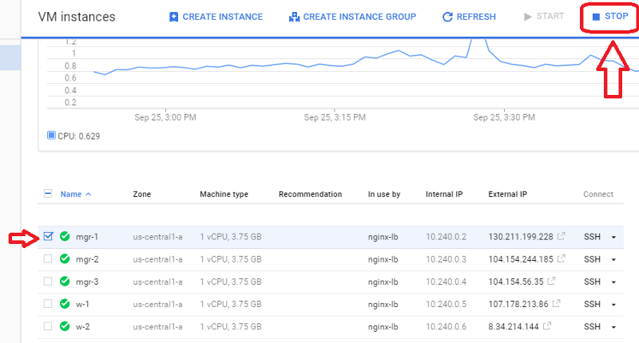

Wait till it has stopped. Now we can SSH into mgr-2 instance and see what is going on:

romin_irani@mgr-2:~$ sudo docker node ls  
ID HOSTNAME STATUS AVAILABILITY MANAGER STATUS  
01.. * **mgr-2 Ready Active Leader**  
4e.. mgr-3 Ready Active Reachable  
6l.. mgr-1 Down Active Unreachable  
7x.. w-1 Ready Active   
8i.. w-2 Ready Active

It is interesting to see that mgr-2 became the Leader. If you hit the Load Balancer IP, everything is still working fine.

Let us look at what happened to our existing container instances. Remember that we had mentioned that we want **6 replicas** of the **nginx** service. And if you recollect, one container was running on **mgr-1.**

romin_irani@mgr-2:~$ sudo docker service ps nginx  
ID NAME IMAGE NODE DESIRED STATE CURRENT STATE   
9z.. nginx.1 nginx mgr-2 Running Running 29 min ago   
6e.. nginx.2 nginx w-1 Running Running 29 min ago   
1o.. nginx.3 nginx w-1 Running Running 29 min ago   
1s.. nginx.4 nginx mgr-2 Running Running 3 min ago   
6n.. \_ nginx.4 nginx mgr-1 Shutdown Running 29 min ago   
8l.. nginx.5 nginx w-2 Running Running 29 min ago   
8p.. nginx.6 nginx mgr-3 Running Running 29 min ago

You will notice that the container nginx.4 which was running on mgr-1 was taken down and relaunched on mgr-2. Looks good!

**Bringing the original Leader back up again**

What happens if we bring mgr-1 back up again. Will it take over as the Leader again, since it was the original leader or will be be a Manager node but cannot become a leader just by coming up again.

It’s straightforward to try this. Simply go to the Cloud console and restart the instance. Wait till the instance is powered on and running:

If you are still in the SSH session on mgr-2, you can try:

romin_irani@mgr-2:~$ sudo docker node ls  
ID HOSTNAME STATUS AVAILABILITY MANAGER STATUS  
01.. * mgr-2 Ready Active Leader  
4e.. mgr-3 Ready Active Reachable  
6l.. mgr-1 Ready Active Reachable  
7x.. w-1 Ready Active   
8i.. w-2 Ready Active

You find that mgr-2 is still the Leader. mgr-1 is now Reachable but did not get instantly promoted to be a Leader.

What about our 6 containers, would some of them get relaunched on mgr-1, just because it came up. Let’s see:

romin_irani@mgr-2:~$ sudo docker service ps nginx  
ID NAME IMAGE NODE DESIRED STATE CURRENT STATE   
9z.. nginx.1 nginx mgr-2 Running Running 35 min ago   
6e.. nginx.2 nginx w-1 Running Running 35 min ago   
1o.. nginx.3 nginx w-1 Running Running 35 min ago   
1s.. nginx.4 nginx mgr-2 Running Running 9 min ago   
6n.. \_ nginx.4 nginx mgr-1 Shutdown Running 35 min ago   
8l.. nginx.5 nginx w-2 Running Running 35 min ago   
8p.. nginx.6 nginx mgr-3 Running Running 35 min ago

Well, it did not! Docker Swarm does not assign containers to newly joined nodes unless the service is scaled or some other nodes are drained and so on. On how to scale, you can follow the [Docker Swarm Tutorial](https://rominirani.com/docker-swarm-tutorial-b67470cf8872#.ydy802bjd) that I earlier wrote.

*Note: You can try scaling the service up by a few more replicas and see what happens. Try it as an exercise.   
Hint:****$ docker service scale nginx=8***

**Bringing a Node down and backup**

This should be straightforward to predict and try out. I will leave it as an exercise for the reader. Just stop **w-1** node and then check on the status of the nodes in the swarm and also how it relaunches containers on the other remaining RUNNING nodes.

*Do keep in mind that as we saw earlier, bringing up the node, does not mean that it will immediately get assigned some containers.*

**Creating another Service**

It is time now to see how the overlay network is working. To reiterate, the overlay network allows containers across multiple hosts to communicate to each other. What this means is that you should be able to simply access any service by its name in any of the containers on the same overlay network.

By referring to the service by its name, it also allows us to scale the number of containers up and down, make them join the swarm and still keep accessing them via a uniform service name.

I am going to use the example from the Docker Swarm overlay network service documentation and use it over here.

First up, we will create a new Docker Swarm service. And then from the containers running this new service, we will see that we can access the service by name.

SSH in mgr-1 or mgr-2 instance. And create the new service as shown below. Note that we are going to use the **same overlay network nw1**.

romin_irani@mgr-1:~$ sudo docker service create --name my-busybox --network nw1 busybox sleep 3000  
azeevpytjcwsfoyvuv2pj4vdu

romin_irani@mgr-1:~$ sudo docker service ls  
ID NAME REPLICAS IMAGE COMMAND  
1e68lm0x00zs nginx 6/6 nginx azeevpytjcws my-busybox 1/1 busybox sleep 3000

romin_irani@mgr-1:~$ sudo docker service ps my-busybox  
ID NAME IMAGE NODE DESIRED STATE CURRENT STATE ERROR  
4elkoyujbyausx7zi5u5i7999 my-busybox.1 busybox mgr-1 Running Running 21 seconds ago

You will notice that in the first command, we are starting up a **busybox**service named **my-busybox**, we want only one replica of it, we are using the same overlay network **nw1**. Notice that we gave a delay of **3000s**so that the container is alive for a while before shutting down because on its own the busybox container will just exit otherwise.

Great! The next command that you see above is the standard service listing and you can see that it has 2 services now: **nginx** and **my-busybox** service.

Similarly, the last command is to find out where the **my-busybox** service containers are running. We find that it is running on **mgr-1**.

Now, let us get into the Bash shell for the running container for the my-busybox service.

romin_irani@mgr-1:~$ sudo docker service ps my-busybox  
ID NAME IMAGE NODE DESIRED STATE CURRENT STATE ERROR  
4elkoyujbyausx7zi5u5i7999 my-busybox.1 busybox mgr-1 Running Running 21 seconds ago

Notice that we have the following attributes:

* NAME is my-busybox.1
* ID is 4elkoyujbyausx7zi5u5i7999

In summary, you can form a unique name for the Container as NAME.ID

To go into the bash shell for this container, execute the following command:

romin_irani@mgr-1:~$ sudo docker exec -it my-busybox.1.4elkoyujbyausx7zi5u5i7999 /bin/sh  
/ #  
/ #  
/ #

Now inside this shell, we can do a lookup for our service **nginx** by name.

/ #   
/ #   
/ # nslookup nginx  
Server: 127.0.0.11  
Address 1: 127.0.0.11

Name: nginx  
Address 1: 10.0.0.2  
/ #   
/ #

You can even do a wget inside over here to validate that we are able to hit the service and get the NGINX default home page:

/ # wget -O - nginx  
Connecting to nginx (10.0.0.2:80)  
<!DOCTYPE html>  
<html>  
<head>  
<title>Welcome to nginx!</title>  
<style>  
 body {  
 width: 35em;  
 margin: 0 auto;  
 font-family: Tahoma, Verdana, Arial, sans-serif;  
 }  
</style>  
</head>  
<body>  
<h1>Welcome to nginx!</h1>  
<p>If you see this page, the nginx web server is successfully installed and  
working. Further configuration is required.</p>  
<p>For online documentation and support please refer to  
<a href="<http://nginx.org/>">nginx.org</a>.<br/>  
Commercial support is available at  
<a href="<http://nginx.com/>">nginx.com</a>.</p>  
<p><em>Thank you for using nginx.</em></p>  
</body>  
</html>  
- 100% |******************************************************************| 612 0:00:00 ETA  
/ #

This shows that we now have a network where each of the services are available to all containers on the network. This way you can link up multiple containers as needed.

Due to the fact that we have a service abstraction now, you can scale your nodes — add / remove them — and not affect the containers that are accessing it by service name. They will not be worried about where the containers are running i.e. on which nodes.

**Conclusion**

I like the simplicity of Docker Swarm and conducting these experiments gave me a good sense of understanding how it is working behind the scenes, what to expect and most importantly, to actually see it work.

Please let me know in the comments if you have any feedback.

*Download a mini book (about 50 pages) that contains both the Docker Swarm Tutorial and Docker Swarm on Google Compute Engine. Click*[*here*](https://goo.gl/w1vMRo)*to download the PDF.*